**Practical No.4**

**Name**: Anuj Rajendra Mane

**Div**: SY A

**Roll No**: 65 **Batch**: A3

**PRN** **No**: 2162701242054

##### Title: Program on Arrays.

**Theory:**

**1: 1D Arrays in java:**

**Declaring Array Variables:**

To use an array in a program, you must declare a variable to reference the array, and you must specify the type of array the variable can reference. Here is the syntax for declaring an array variable.

**In Java, here is how we can declare an array**

dataType arrayName[];

dataType - it can be primitive data types like int, char, double, byte, etc.

arrayName - it is an identifier

**For example:**

double data[];

Arrays are nothing but a data structure that is used to hold the data elements of the same type in a sequential fashion.

**Initialization of Arrays in Java:**

In Java, we can initialize arrays during declaration. For example,

//declare and initialize and array

int age[] = {12, 4, 5, 2, 5};

Here, we have created an array named age and initialized it with the values inside the curly brackets.

Note that we have not provided the size of the array. In this case, the Java compiler automatically specifies the size by counting the number of elements in the array (i.e. 5).

In the Java array, each memory location is associated with a number. The number is known as an array index. We can also initialize arrays in Java, using the index number. For example,

// declare an array

int[] age = new int[5];

// initialize array

age[0] = 12;

age[1] = 4;

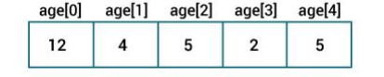age[2] = 5;

**Accessing Elements of an Array in Java:-**

We can access the element of an array using the index number. Here is the syntax for accessing elements of an array,

// access array

elements array[index];

Let's see an example of accessing array elements using index numbers.

**Example: Access Array Elements:**

class Main {

public static void main(String[] args) {

// create an array

int age[] = { 12, 4, 5, 2, 5 };

// access each array elements

System.out.println("Accessing Elements of Array:");

System.out.println("First Element: " + age[0]);

System.out.println("Second Element: " + age[1]);

System.out.println("Third Element: " + age[2]);

System.out.println("Fourth Element: " + age[3]);

System.out.println("Fifth Element: " + age[4]);

}

}

**Output Accessing Elements of Array:**

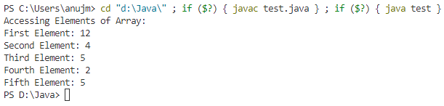

**Looping Through Array Elements**

In Java, we can also loop through each element of the array.

**For example, Example: Using For Loop**

class Main {

public static void main(String[] args) {

// create an array

int age[] = { 12, 4, 5 };

// loop through the array

// using for loop

System.out.println("Using for Loop:");

for (int i = 0; i < age.length; i++) {

System.out.println(age[i]);

}

}

}

**Output:**

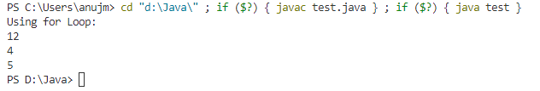

**Example:-** One dimensional array is used to at educational platforms, also in various industries for storing the important info. In Educational platform it is used to store student roll no or student name etc…

**2D Arrays In java:**

The manner in which multidimensional arrays are represented makes them quite flexible. In fact, the lengths of the rows in array b are not required to be the same. A multidimensional array with the same number of columns in every row can be created with an array-creation expression.

**Syntax:-  
 Datatype_variablename[NO.Of Rows][No.Of Coloumns];**

**Example:-** The Two Dimension array is used in day-to-day life examples.  
 Array multiplication, A tray of eggs. A muffin baking tin.Fence. A chocolate box.

**Program**:

import java.util.Scanner;

class Easy {

public static void main(String[] args) {

Scanner in = new Scanner(System.in);

int a[][] = new int[3][3];

int i, j;

System.out.println("Enter 9 value one by one");

// taking input

for (i = 0; i <= 2; i++)

for (j = 0; j <= 2; j++)

a[i][j] = in.nextInt();

// printing element of array

System.out.println("Element is given below");

for (i = 0; i <= 2; i++) {

for (j = 0; j <= 2; j++) {

System.out.print(a[i][j] + " ");

}

System.out.println("");

}

}

}

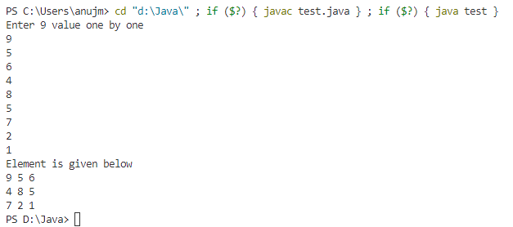

**Conclusion:**

I can learn the basic concepts of array. There are three types of array 1D Array, 2D Array, & Multidimensional array. I can do the all types of programmes.

**Completion Date: Co-Ordinator Sign:**